

**QUOTATION**

217, Sheik Rasheed Building, Hor Al Anz East, Dubai

[www.verbat.com](http://www.verbat.com) | [uae@verbat.com](mailto:uae@verbat.com)

Tel: 00971 4 2973236

|  |  |  |  |  |
| --- | --- | --- | --- | --- |
|  | | |  |  |
| Quotation Date | Quotation No. | Contact Person | | Contact No. |
| **Q/WAD/26122016/999/1**  **26 Dec 2017** |  | **Ms. Deepthi Krishna** | | **04-2973236** |

**Cost Break up**

|  |  |
| --- | --- |
| **No** | **Services offered** |
| 1 | UAE-HUB : Developing Web Application for the client admin/HR/Management and native Android & iOS mobile app (English & Arabic) for employees as per the scope of work defined under Phase 1 in this document |

**THE SOLUTION**

**Scope of work**

Jumestores proposes to develop a mobile & web based internet ecommerce application that sells a wide range of versatile products including consumer electronics, health & beauty products, household appliances, and groceries. Provision should be made to add new items to the website daily.

Native Android and IOS apps shall also be developed to support the ecommerce application. product from to sell a that can be used by its employees.

The primary components of the application will consist of

* E-Commerce store to display products category wise
* Multi touchpoint contact options
* User registration
* Add promotions and special offers
* Create Wish list for users
* Related items for selected products
* Intelligent search with product filters
* Shopping cart
* Leave reviews for products
* Advanced payment options
* Social media integration
* Detailed Shipping information
* Viable product return options
* Back office functionality to manage inventory and prices
* Security (SSL, 2 factor authentication
* General pages (About us, contact us, Privacy Policy, Newsletter etc.)

**The application will have web and mobile interface which will be developed simultaneously**

**Web Module**

* Responsive Design
* User Registration
* Authentication and Authorization
* Related products, suggestions & wish list
* Shopping cart
* Product Comments and ratings
* Unlimited product categories, products and manufacturers
* Intelligent product search with filters
* Integration with payment gateway
* Promotions and special offers
* Social media integration
* Multi touch point contact options

**Admin Features:**

* Add new Categories and Products (Product uploads)
* Create discounts for customers (special offers & discounts)
* Analytics, event notification system and reporting
* Manage Site content
* Manage user groups, User & Roles ( Site admins, Store managers)
* Manage Stock, Orders, Returns & Prices

**Security**

* Hosted in a Dedicated server with Firewall
* 128 Bit SSL

**Mobile (Android & IOS)**

* Authentication & authorization
* User Registration
* Welcome screen & Dashboard
* Category Menu
* Related products, suggestions & wish list
* Shopping cart
* Product Comments and ratings
* Unlimited product categories, products and manufacturers
* Intelligent product search with filters
* Integration with payment gateway
* Promotions and special offers
* Social media integration

**Phase I Deliverables**

* **Stage 1 Design**
  + Project plan
  + Prototype/Entire Design Wireframe
* **Stage 2 Development**
  + Application framework
  + Web Application Development - Admin /HR / Management
  + Mobile (native iOS & Android) Application Development
  + API Development
* **Stage 3 Testing**
  + Quality Assurance (QA)-Verbat
  + User Acceptance Testing (UAT)-client
* **Stage 4 Go Live**
  + Web Application deployment on server

**Please note:**

* + Mobile application deployment to Play store & App store
  + Deployment to client’s server

**Solution Diagram**

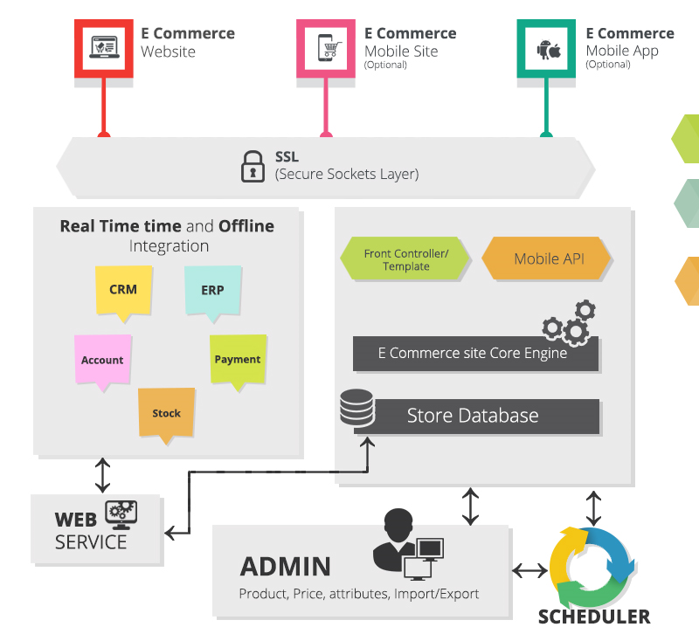

Video viewed & liked

**THE PROJECT SCOPE**

* Design Prototype/Wireframe
* Developing the Ecommerce application along with native mobile applications in IOS and Android
* Testing & Bug Fixing
* Release of the application for UAT to the client
* Application deployment
* Mobile application deployment to Play store & App store

**ASSUMPTIONS**

The project solution and technology is created from the initial understanding of the requirement shared with Verbat through mails and meetings. The proposed solution is based on the following assumptions;

Objective:

* To develop a web based application and mobile application with the functionalities as defined in the section titled “The Solution”.

Design:

* Client to provide Verbat with the branding guidelines if any
* The proposed web application will be in English and the mobile application will be in English

Development:

* Detailed system study is required before the start of the project.
* In order to access the Verbat proposed system, client should have internet connectivity.
* Client will provide sample data and devices for testing.
* Verbat assumes that all sign-offs from Client will be provided within agreed and specified timeframe.
* The system assumes that the server where the application would be hosted will have internet connectivity.